NATaT Federal Platform for the 119th Congress

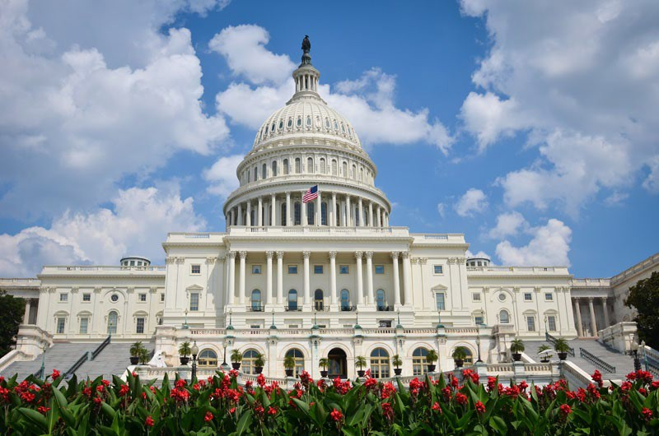

[**www.natat.org**](http://www.natat.org/)

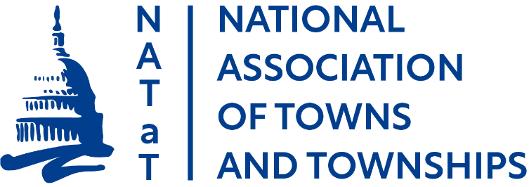

**Federal Priorities for the 119th Congress**

# Infrastructure

## Transportation Reauthorization

## NATaT supports direct, guaranteed funding to local roads and bridges. Towns and townships in many NATaT-member states manage more miles of road than any other government entity in their states. Federal funds flow directly to state departments of transportation and to metropolitan planning organizations but rarely make their way to the towns and townships that are responsible for maintaining the roads. NATaT supports a solution in transportation reauthorization that guarantees direct and consistent funding for locally owned roads and bridges.

* NATaT supports the U.S. Department of Transportation’s (USDOT’s) Off-System Bridge program, which funds state and local bridges that are not on the Federal-aid Highway system. However, many of the nation’s “bridges” that need repair and replacement are not eligible because they do not meet the federal definition of a bridge. Federal regulations define a bridge as a structure having a span greater than 20 feet (23 CFR 661.17(a)(1)). NATaT supports increased funds for the federal bridge program that are provided to states for non-state structures less than 20 feet, which states must distribute through a competitive process based on condition and economic need.
* NATaT opposes efforts to increase the national truck weight limit on the federal highway system, and efforts to allow longer, wider double- and triple-trailer trucks on federal highways.
* NATaT wants to ensure that any effort to impose vehicle miles traveled fees considers the limited transportation options for rural residents and the resulting need to use their vehicles to access work and daily services.
* NATaT encourages the USDOT to prioritize funding projects in rural areas. NATaT also wants to ensure that DOT understands the reality of the current “rural” definition, which is an area that is outside an urbanized area with a population of less than 200,000. To our nation’s towns and townships, 200,000 is not “rural.”
* NATaT supports the *Rebuilding Rural Roads Act* and *Protecting Infrastructure Investments for Rural America Act* that address DOT’s definition of “rural” in the Rural Surface Transportation Grant Program.
* NATaT supports competitive grant programs that fund vital safety projects in our communities. The Safe Streets and Roads for All grant program, created and funded through the *Infrastructure Investment and Jobs Act*, is aimed at reducing roadway fatalities and serious injuries. The program focuses on making streets safer for everyone. NATaT supports its authorization. NATaT also supports reauthorization of the Consolidated Rail Infrastructure and Safety Improvements grant program, which funds rail safety and service improvements, such as rail crossing improvements, upgrading track, and replacing or rehabilitating aging bridges.

## Other Transportation

* NATaT supports efforts to increase the federal volunteer driver mileage reimbursement (14¢/mile) to equal the federal business driver mileage reimbursement (70¢/mile).

## Farm Bill

* NATaT supports a Rural Development Title that promotes economic growth and stability by investing in our nation’s rural infrastructure, incentivizes regional collaboration, and ensures the success of our next generation of farmers. We support federal efforts to connect rural American communities, homes, farms, businesses, first responders, educational facilities, and healthcare facilities to reliable and affordable high-speed internet services.

## Telecommunications and Cybersecurity

* NATaT supports federal efforts to reform the Universal Service Fund (USF) contribution system that will provide predictable and sustainable funding for the High Cost/Connect America Fund, Lifeline, Schools and Libraries, and Rural Health Care programs. NATaT is concerned that recent calls to fund USF programs through the annual congressional appropriations process would subject these programs to the uncertainty of the annual budget process, likely disrupting long-term planning and investments in broadband networks and services, particularly in rural and high-cost areas.
* NATaT supports federal efforts to prioritize broadband infrastructure deployment to unserved and underserved areas, including federal programs that support satellite internet services to more rural or remote areas.
* NATaT supports federal efforts to ensure coordination and planning amongst federal, state, and local governments to maximize the efficient and effective use of federal funds to expand broadband access in unserved and underserved rural areas.
* NATaT supports federal efforts to streamline broadband infrastructure deployment *without* preempting local control over public rights-of-way, including land use, permitting, and siting processes – tenets of a community’s right to self-govern.
* NATaT opposes federal efforts that restrict local governments, cooperatives, and utilities from providing broadband services.
* NATaT supports federal efforts to provide technical assistance and funding to local governments to mitigate cybersecurity risks.
* NATaT supports the efforts of the Rural Broadband Caucus in both the House and Senate to facilitate discussion, educate Members of Congress, and develop policy solutions to close the digital divide in rural America.

# Tax

* NATaT supports preserving the tax-exempt status of municipal bonds that have helped build public infrastructure for more than 200 years. These bonds enable state and local governments to access necessary capital for critical infrastructure projects. NATaT also supports reinstating advance refunding bonds to allow a community to refinance a municipal bond and maintain the bond’s tax-exempt status.
  + NATaT supports the efforts of the House Municipal Finance Caucus as a forum to discuss the opportunities and challenges for local governments to fund initiatives that strengthen our communities, and to advocate for bipartisan policies that enhance our access to capital markets.
* NATaT supports maintaining the tax-exempt status of 501(c) organizations. Congress first exempted associations from most taxes in recognition of their public benefits. Associations earn their tax-exempt status because they exist to serve the public good rather than to benefit private individuals or generate profit. This tax-exempt status allows associations, like ours, to focus on their unique and important missions without the constraint of profit maximization, ensuring that they can continue to serve their members and broader communities effectively. Any change to the tax-exempt status of nonprofit associations would be woefully disruptive to the critical work NATaT and our member state organizations are doing on behalf of towns and townships across the country.
* NATaT supports eliminating or increasing the cap on state and local tax (SALT) deductions. Given the significant appreciation in home values nationwide, the $10,000 limit on the SALT deduction for federal income taxes poses a substantial hardship for many families. NATaT supports eliminating or substantially increasing the SALT cap.
* Generally, NATaT supports efforts to strengthen and expand the federal Low-Income Housing Tax Credit (LIHTC) Program, which plays a key role in financing affordable housing, to increase available credits and make tax credit equity usage more efficient. Millions of affordable homes have been constructed, preserved, or rehabilitated utilizing the LIHTC program. NATaT supports increasing allocations of nine percent housing tax credits to states by 50 percent. These credits are an extremely successful and efficient method for facilitating the production and rehabilitation of affordable housing across the country. On average, 50 percent of the total financing for nine percent LIHTC projects comes from the equity derived from the credit. However, NATaT opposes any legislative language that prohibits considering local support or contributions to a project in the selection criteria. It is essential to preserve local authority in making development decisions.

# Volunteer First Responders

* NATaT supports congressional efforts to establish incentive programs to recruit and retain volunteer first responders. Volunteer firefighters alone save communities of all sizes $129 billion a year, and represent 71% of all firefighters in the U.S. Of the total number of volunteer firefighters, 95% service communities with a population of 25,000 or less.
* NATaT supports legislation that would expand existing federal housing assistance programs to qualified volunteer first responders.
* On February 5, 2024, the Occupational Safety and Health Administration (OSHA) published a Notice of Proposed Rulemaking (NPRM) to modernize the agency’s “Fire Brigades” standard with a proposed new “Emergency Response Standard.” While many provisions in the proposed Emergency Response Standard would enhance emergency responder safety, some would be overly burdensome or even unfeasible for volunteer fire and emergency service departments to implement. If the standard is adopted in its current form, many departments would be forced to shut their doors or else operate outside of the federal standard, leaving themselves open to fines, citations, and civil liability exposure. The Trump administration placed a pause on all pending regulatory actions (including the Emergency Response Standard) pending further review. NATaT opposes the proposed standard in its current form, as it would have a devasting impact on the volunteer fire and emergency service departments upon which most of our towns and townships rely.

# Unfunded Mandates and Federal Preemption

* Local authority must be preserved. NATaT opposes any effort by the federal government to preempt local authority. NATaT appreciates administration and congressional efforts to make housing more affordable. However, it is imperative that local governments maintain authority relative to zoning and land use decisions. Local government is actively engaged in helping increase housing stock in a fair and locally sensitive way. Federal preemption of this local authority would have a devastating impact on our communities.
* NATaT strongly supports legislation that would require the federal government to provide adequate and necessary funding sufficient to implement and administer any mandate imposed on local government, including the Financial Data and Transparency Act that requires local governments that receive municipal securities to adhere to new financial data standards and put their financial information in machine-readable format. NATaT opposes any expansion of these financial reporting requirements to federal loan and grant programs.
* NATaT supports a common-sense definition of the *“Waters of the U.S.”* rule without unnecessarily expanding the jurisdiction of the Clean Water Act.
* NATaT opposes efforts by the U.S. Environmental Protection Agency to require that all municipalities, regardless of how small, be mandated to obtain a National Pollutant Discharge Elimination System permit for their municipal stormwater management systems.

# Federal Funding

* NATaT supports efforts to control federal spending but supports increased, or at least level funding for those federal programs that promote local economic development, create jobs, and generate tax revenues for all levels of government. They include USDA’s Rural Development programs; FEMA’s State and Local Programs, particularly Fire Act Grants; Economic Development Administration programs; and National Telecommunications and Information Administration broadband-related programs.
* NATaT urges Congress to authorize reasonable fees to recapture expenses for the provision of local government services to federal facilities and lands.
* NATaT supports budget allocation policies that are fair to towns and townships. A disproportionate amount of federal funds is directed to larger metropolitan communities. Notably, larger communities have significant needs, but so do our nation’s smaller communities. Allowing smaller local governments to access funding directly, and in the same manner as large municipalities, will enhance job creation and economic development in communities throughout the country. NATaT supports continued direct funding for ALL units of local government as were included in the American Rescue Plan Act.



[**www.natat.org**](http://www.natat.org/)

**For more information, contact NATaT Federal Director Jennifer Imo at** [**202.679.2243/jimo@tfgnet.com**](mailto:202.454.3947/jimo@tfgnet.com)

[**www.natat.org**](http://www.natat.org/)

**For more information, contact NATaT Federal Director Jennifer Imo at** [**202.454.3947/jimo@tfgnet.com**](mailto:202.454.3947/jimo@tfgnet.com)

The National Association of Towns and Townships (NATaT) is the voice for more than 10,000 towns and townships across the country seeking to enhance the ability of smaller communities to deliver public services, economic vitality, and good government to their citizens. America’s towns and townships seek to partner with the federal government to ensure that public laws, policies, regulations, and resources support our role in fostering local democracy.

There are approximately 39,000 units of local government in the United States. Of that number, 85 percent serve communities with less than 10,000 people and nearly half have fewer than 1,000 residents. Approximately one quarter of all Americans live in rural areas, roughly the same percentage as live in central cities. NATaT was formed more than 40 years ago to provide those smaller communities a strong voice in Washington, D.C. NATaT’s purpose today, as it was then, is to champion pro-town and -township federal initiatives and to promote legislative and regulatory policies designed to strengthen smaller units of local government.

NATaT has developed a proactive federal agenda to ensure that the needs and interests of the nation’s smaller communities are reflected in all major federal statutory, regulatory, funding, and policy decisions made in Washington. NATaT is eager to work in collaboration with the other local government associations, the Administration, and Congress to achieve these goals.

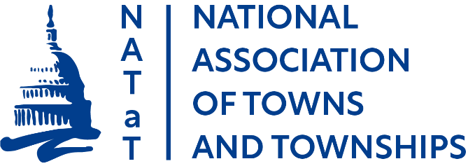**NATaT members include town and township officials represented by the following state associations:**

Township Officials of Illinois Michigan Townships Association Minnesota Association of Townships

Association of Towns of the State of New York North Dakota Township Officers Association Ohio Township Association

Pennsylvania State Association of Township Supervisors

South Dakota Association of Towns and Townships

Wisconsin Towns Association